Section 1: Given a TreeMap<Long,Contact> which has phone numbers for keys and contact objects for values.

Write solutions to

a.Fetch all the keys and print them.

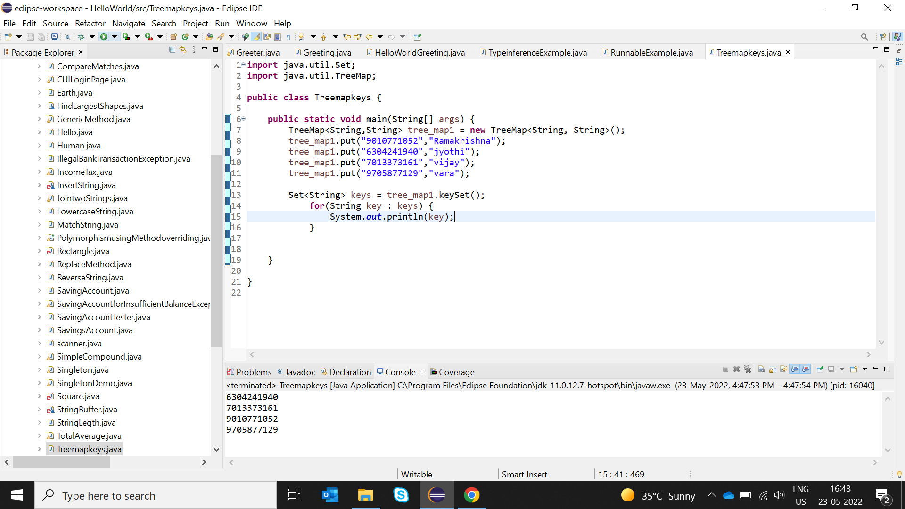

b.Fetch all the values and print them.

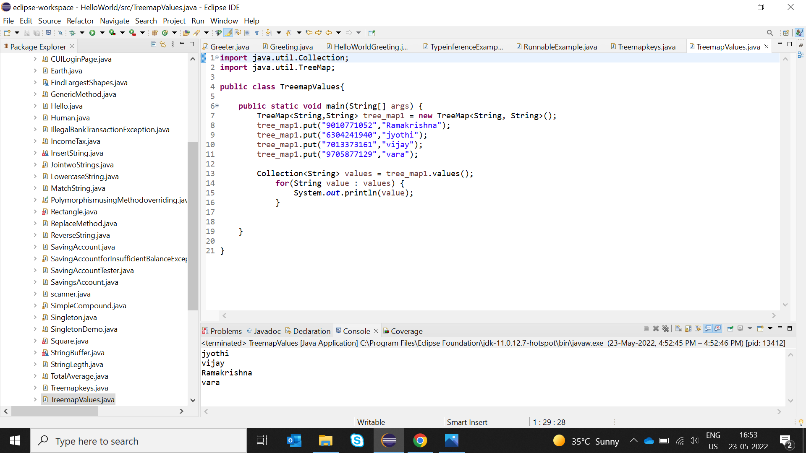

c.Print all key-value pairs.

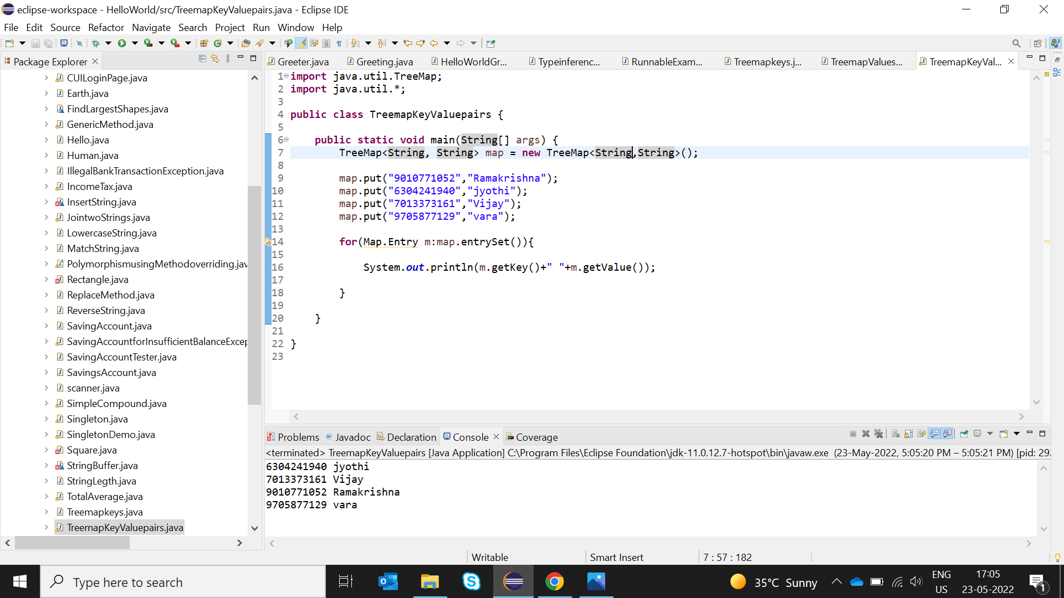

Section2: Write an application to store 10 unique product objects. In cas there is an attempt to add a duplicate product,it should be silently rejected. Hint: Use HashSet or TreeSet.

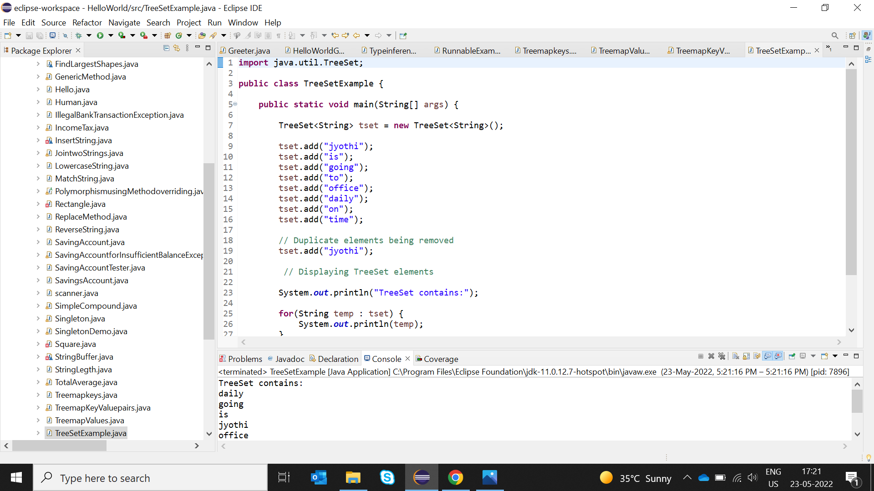

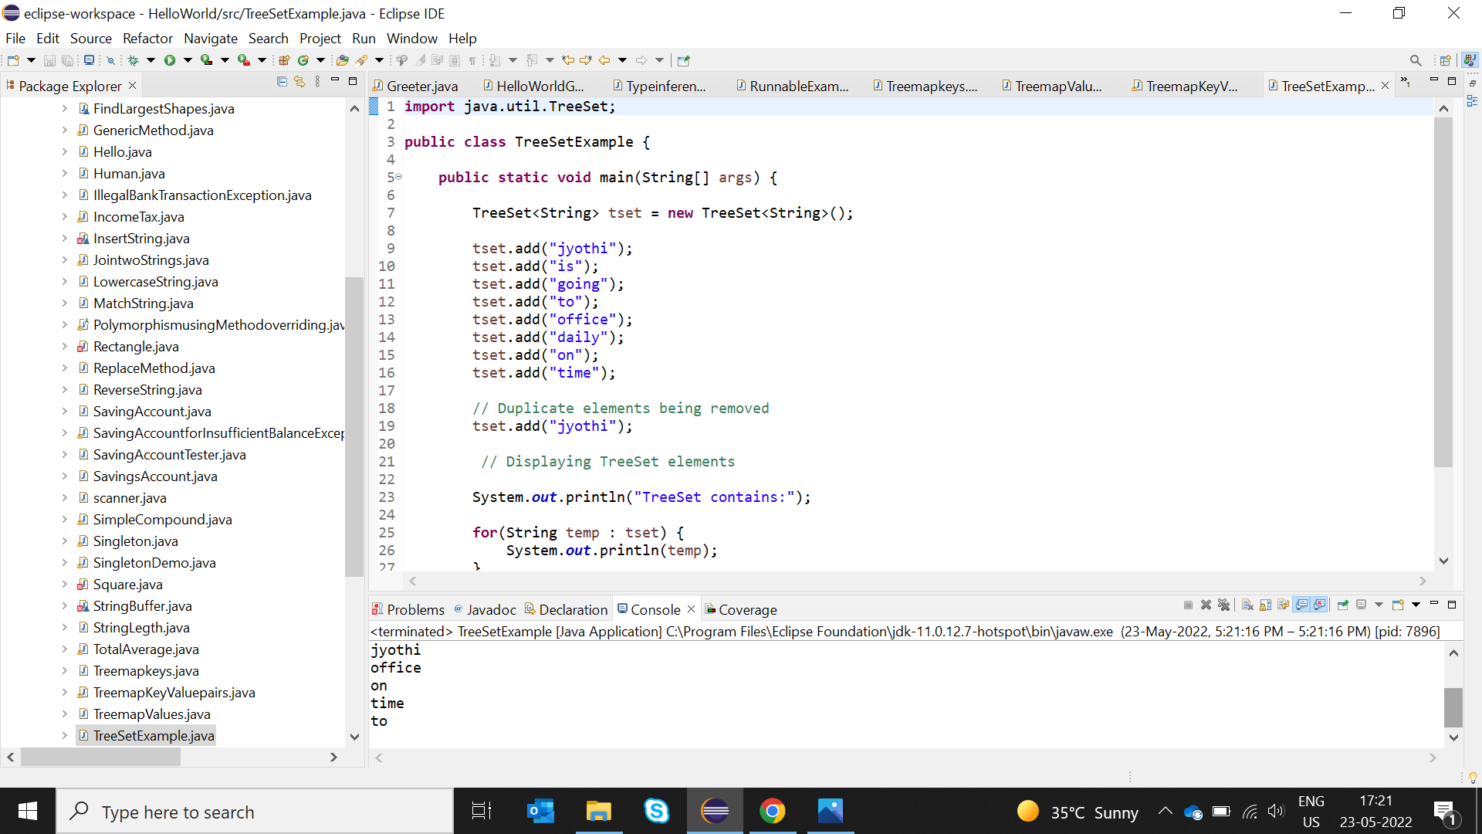

Section3: Store at least 10 Employee Objects in an TreeSet<Employee>. When the application runs the user should be asked to select one of the options upon which you will print the employee details in a sorted manner.

For E.g.

Run Application:

a)ID

b)Name

c)Department

d)Salary

your choice:b

<should print all the employee’s details sorted by name>

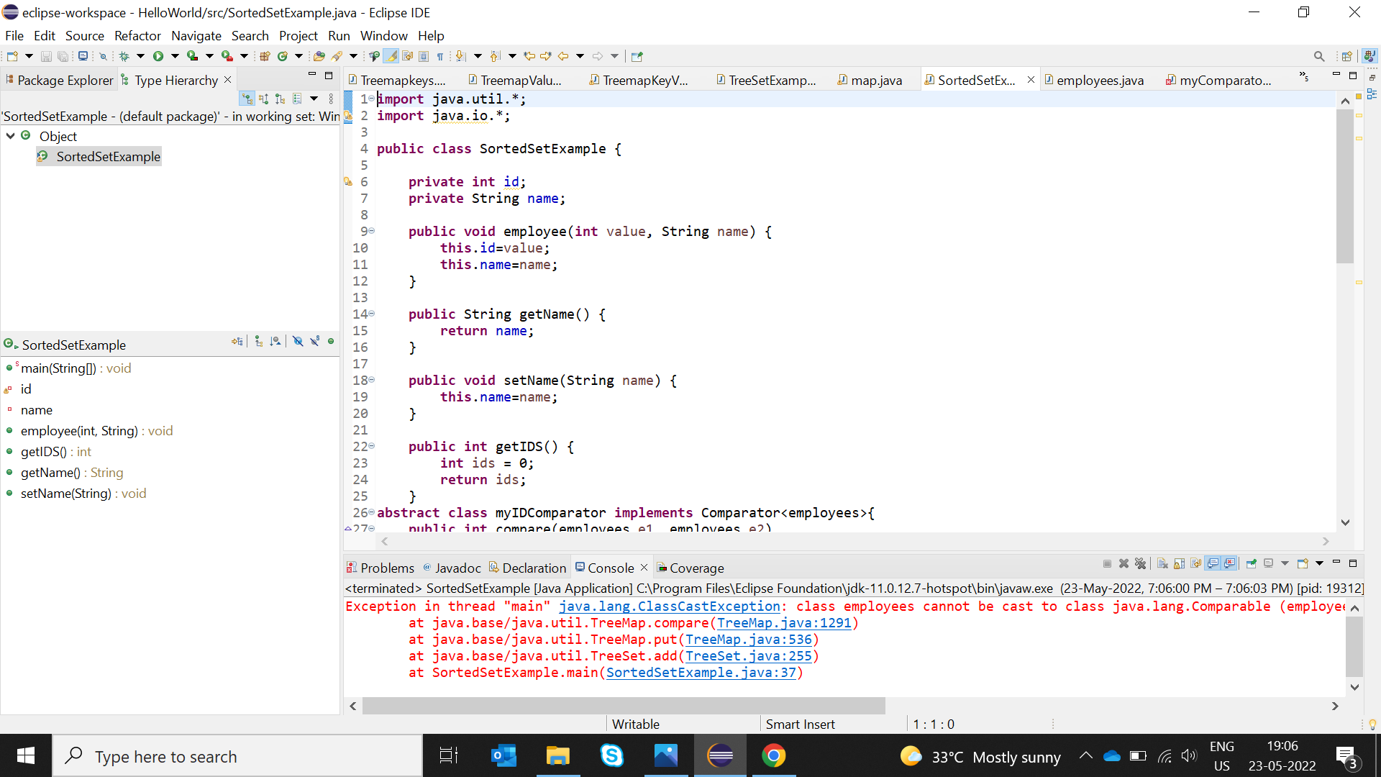

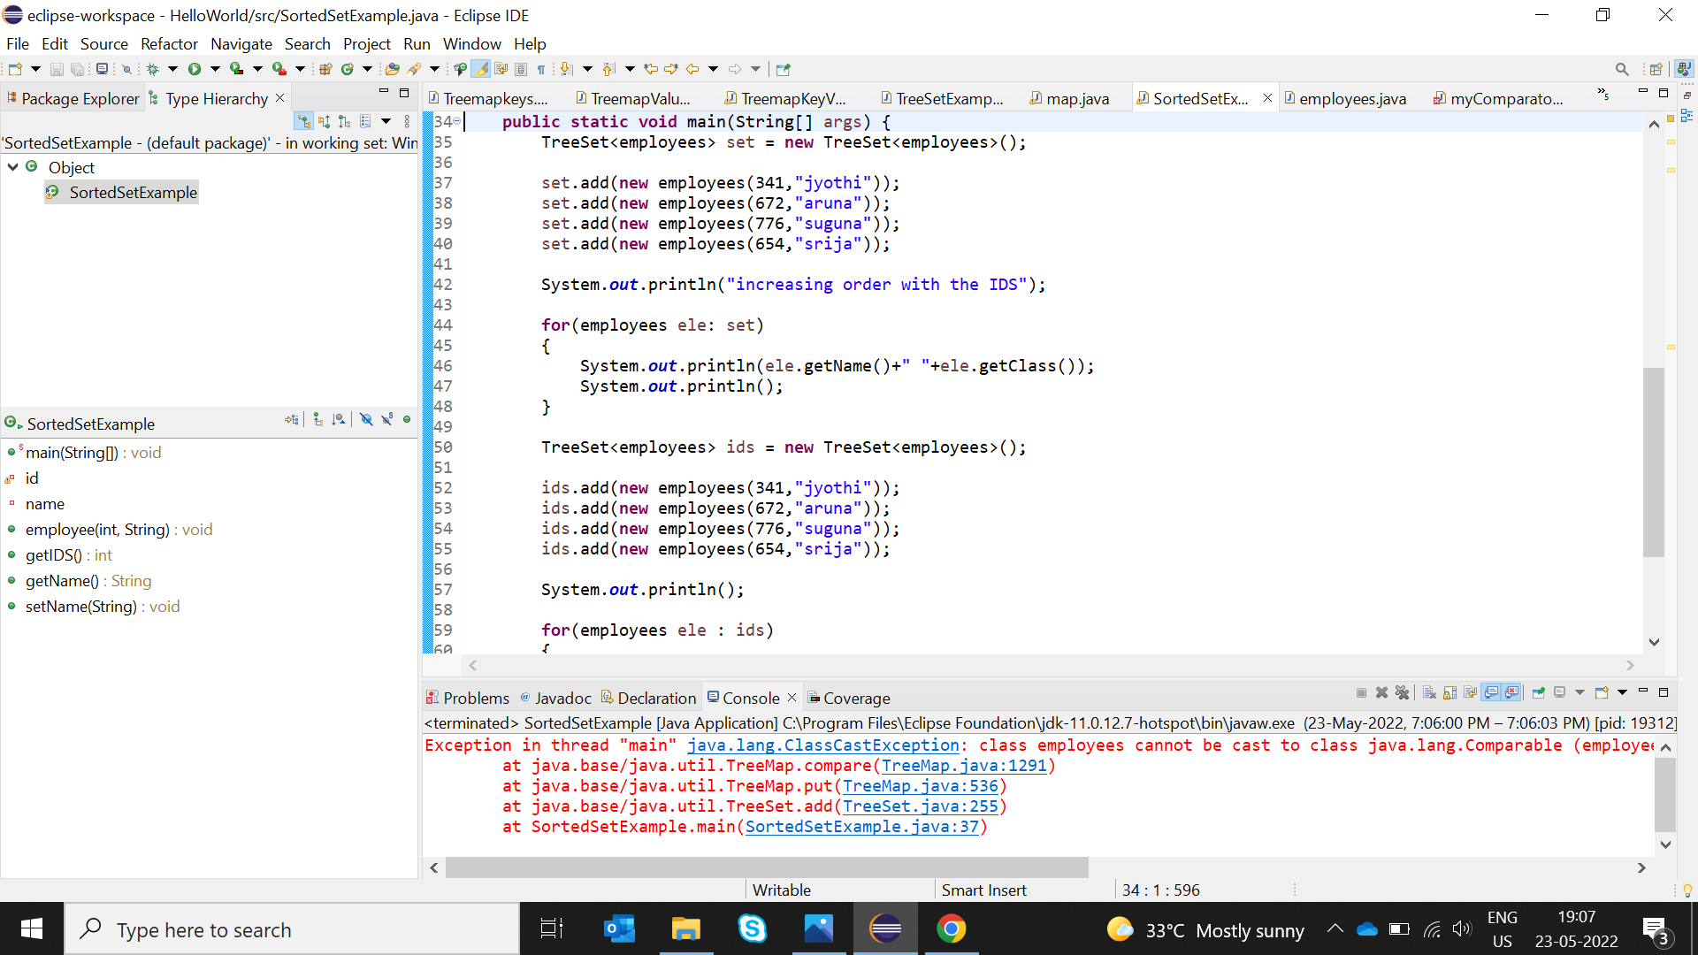

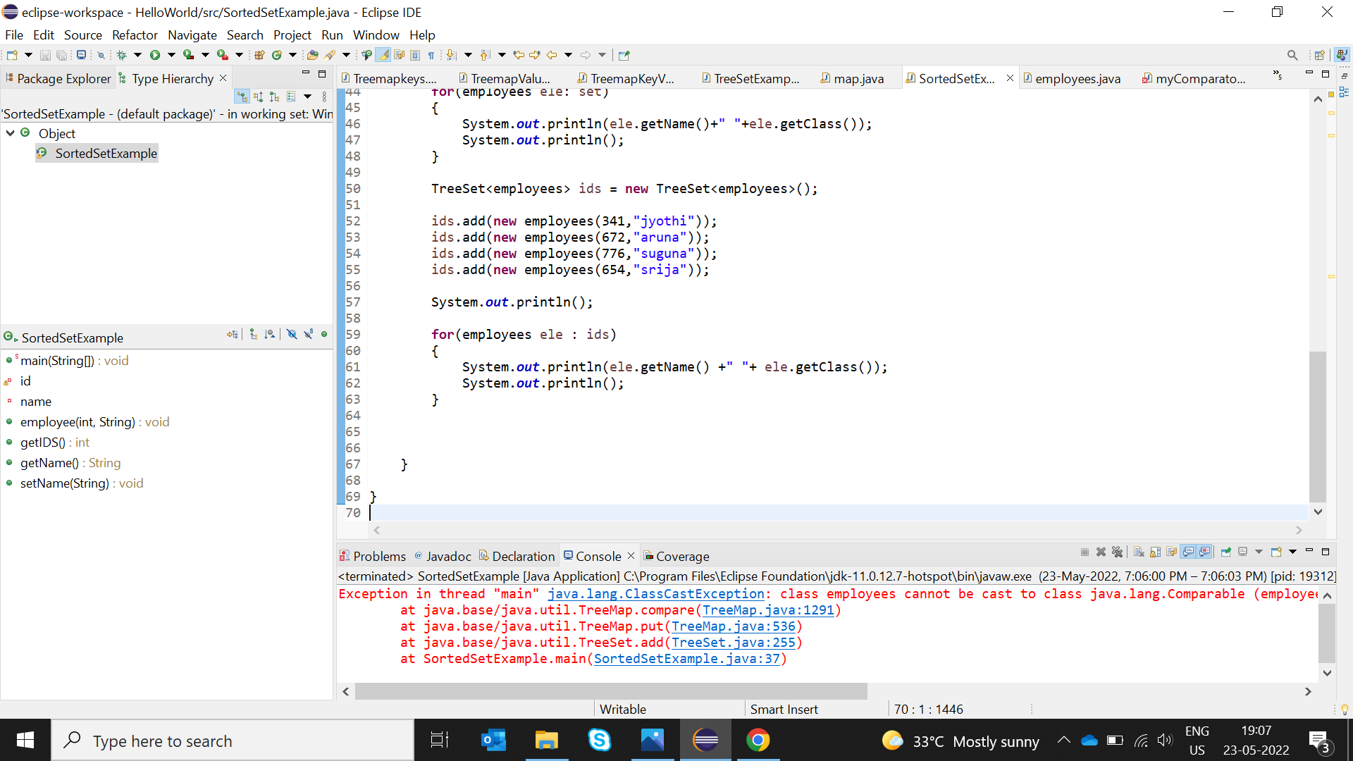

Section4: Given a LinkedList of Objects representing date of birth’s(use any inbuild java class to represent date),print the date’s along with the message: Your date of Birth is DD-MM-YYYY, and it (was or was not) aleap year.

E.g.

a)For the date 23-12-2000

your date of birth is 23-12-2000 and it was a leap year.

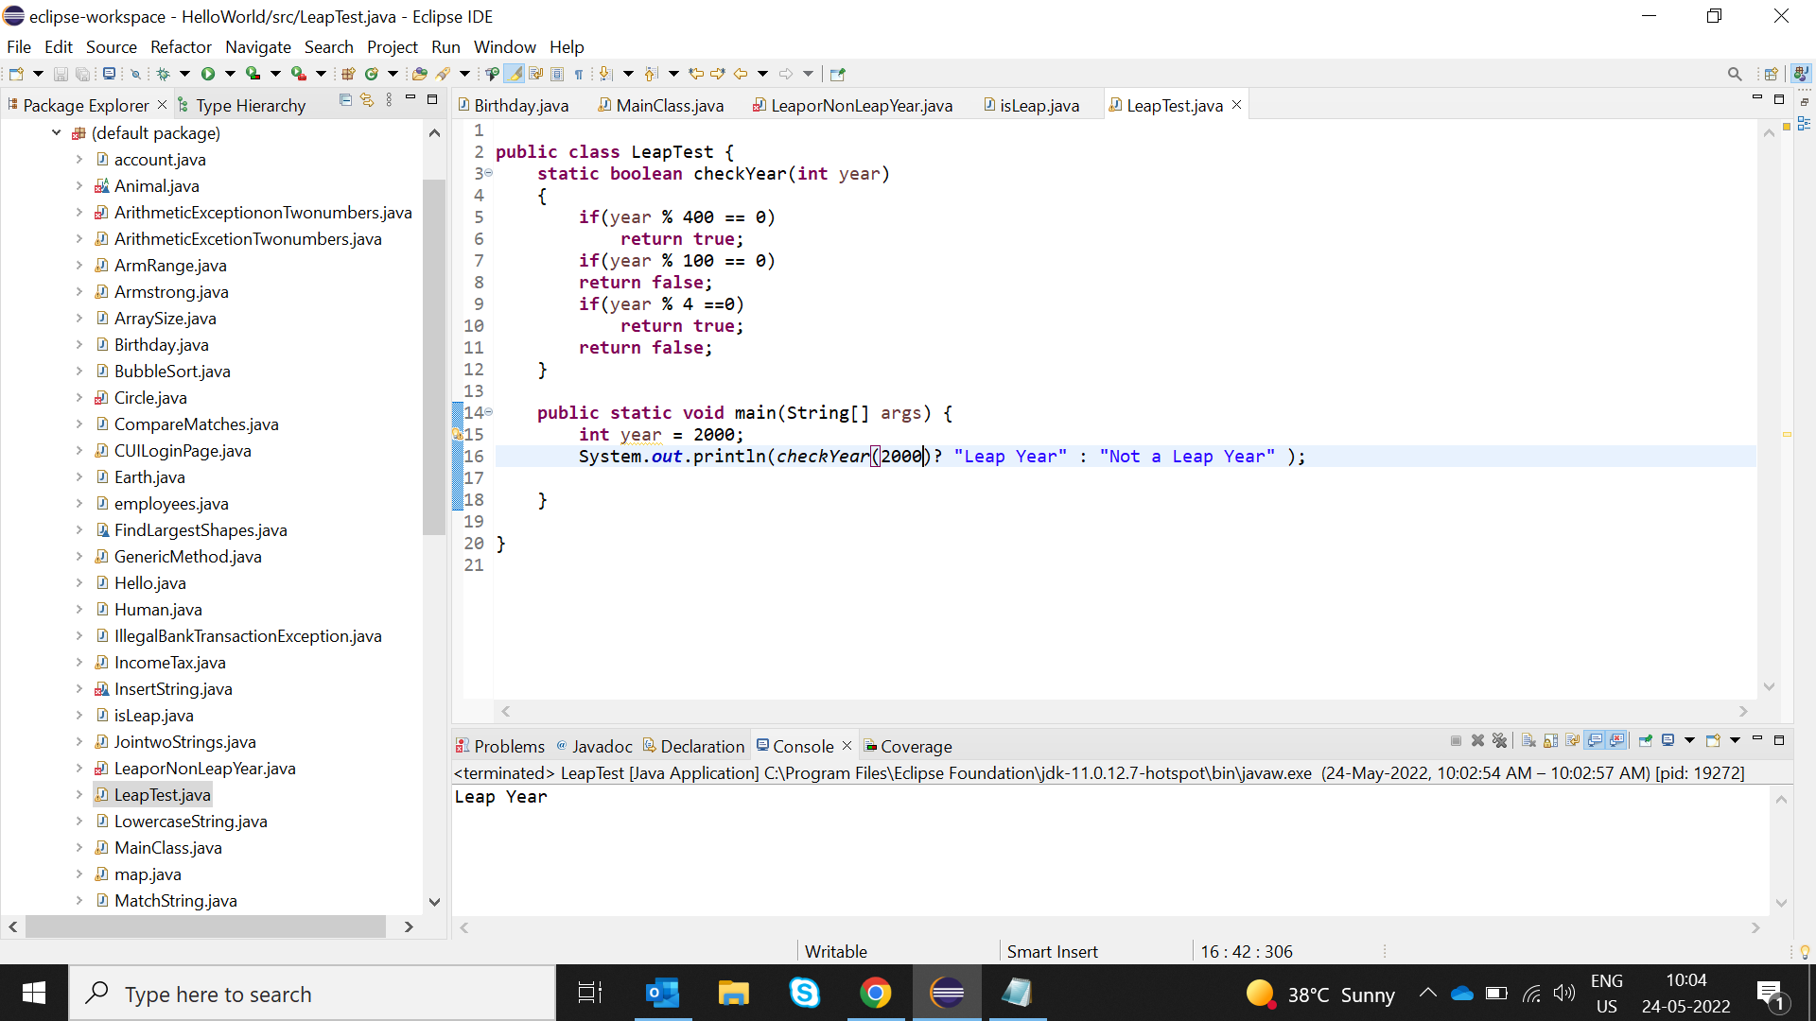

b)For the date 23-12-2001

Your date of birth is 23-12-2000 and it was not a leap year

